
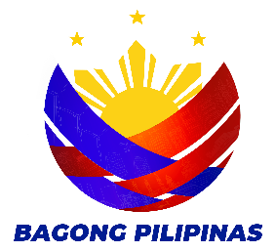
COLLEGE OF COMPUTER STUDIES AND TECHNOLOGY
MIDTERM EXAMINATION IN IT PROF EL 5 –
ADVANCE GAME DEVELOPMENT
FIRST SEMESTER AY 2026-2027

DALUBHASAAN NG LUNSOD NG SAN PABLO

Patriotism • Leadership • Service • Professionalism
NAME: ___________________________________ SCORE : _______
PROGRAM/SECTION: INSTRUCTOR: __________________

TEST I. MULTIPLE CHOICE. Choose the best answer for the following questions. Encircle the letter of the correct answer.

1. What is RPG Maker MV primarily used for?
A. Creating spreadsheets
B. Making role-playing games
C. Editing photographs
D. Creating presentation slides

2. Who can play games created using RPG Maker MV?
A. Only RPG Maker MV users
B. Only game developers
C. Users who do not have RPG Maker MV
D. Only Windows users

3. What format are games created using RPG Maker MV now available in?
A. HTML5
B. PDF
C. MP3
D. DOCX

4. Which of the following is an environment where RPG Maker MV games can be distributed?
A. Windows
B. Mac OS X
C. Android
D. All of the above

5. What does the map represent in an RPG Maker MV game?
A. The game's sound system
B. The world in which the game takes place
C. The game's database
D. The game's programming language

6. What happened to the game resolution in RPG Maker MV?
A. It decreased from 816×624 to 544×416
B. It remained at 544×416
C. It increased from 544×416 to 816×624
D. It increased from 640×480 to 1024×768

7. What can now be automatically overlapped in RPG Maker MV?
A. The upper two tiles
B. The lower two tiles
C. The first two maps
D. The first two characters

8. What mode can users switch to using the Tile Palette tab?
A. Database Mode
B. Region Editor Mode
C. Battle Mode
D. Testing Mode

9. What is the new maximum number of tiles for regions?
A. 63
B. 100
C. 200
D. 255

10. What is the purpose of the enhanced Region Editor feature?
A. To edit regions in more detail
B. To create sound effects
C. To edit character dialogue
D. To increase game resolution

11. How can a created map be saved as an image?
A. By selecting Export Map from the File menu
B. By selecting Save as Image from the map list's context menu
C. By pressing the Play button
D. By using Region Editor Mode

12. What type of plugins are included with RPG Maker MV?
A. User-created plugins only
B. Official plugins
C. Third-party plugins only
D. Browser plugins

13. What can users do with the official plugins included in RPG Maker MV?
A. Use them right from the start
B. Use them only after completing a game
C. Use them only with another game engine
D. Use them only online

14. What is the maximum number of entries that can be configured for skills, items, weapons, armors, enemy characters, and enemy groups?
A. 255
B. 500
C. 1,000
D. 2,000

15. Where can messages traditionally changed via scripts now be managed and changed?
A. Region Editor
B. Terms tab
C. Tile Palette
D. Map List

16. Where can equipment types such as arm equipment and leg equipment be increased or decreased?
A. Terms
B. Plugins
C. Types
D. Region Editor

TEST II. MODIFIED TRUE OR FALSE. Read each statement carefully. Write TRUE if the statement is correct. If the statement is FALSE, underline the incorrect word and write the correct word in the space provided.

- Side-view Battle allows actors to be displayed on the Battle Screen.
- The OFF setting for Use Side-view Battle enables Side-view Mode.
- Magic Skills configures Skill Types that require chanting motions.
- Attack Motions sets an animation for each type when attacking.
- Actor: Battler sets the image of actors displayed during battle.
- State: Motion sets the image displayed over the actor according to the actor's state.
- State: Overlay sets an image displayed over the actor's image according to the actor's state.
- Plugin Commands is found under the Advanced category of the additional event commands.
TEST III: ENUMERATION. Read each item carefully and write your answers in the spaces provided.

A. Enumerate at least eight (8) Basic Editor Controls in RPG Maker.
1.
2.
3.
4.
5.
6.
7.
8.

B. Enumerate at least eight (8) items found in the Menu Bar in RPG Maker.
9.
10.
11.
12.
13.
14.
15.
16.

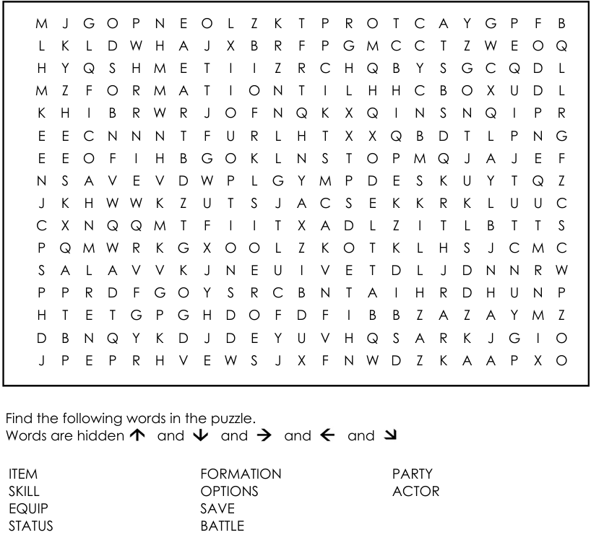
TEST IV: WORD SEARCH. Locate and circle (or highlight) the hidden terms in the grid below. Words may appear horizontally, vertically, or diagonally, forwards or backwards.

PREPARED BY: | REVIEWED BY: | APPROVED BY: | NOTED:
KENDRIX B. BROSAS | ELLEN B. GUIA | JORDAN M. PUHAWAN, MSIT | ROSIELL U. CONSIGNADO, MSIT
LEAD INSTRUCTOR, IT PROF EL 5 | DEPARTMENT CHAIR, BSIT | PROGRAM CHAIR, BSIT | DEAN, COLLEGE OF COMPUTER STUDIES AND TECHNOLOGY
Date: | Date: | Date: | Date:

ANSWER KEY:
1 | B
2 | C
3 | A
4 | D
5 | B
6 | C
7 | A
8 | B
9 | D
10 | A
11 | B
12 | B
13 | A
14 | D
15 | B
16 | C
17 | TRUE
18 | FALSE – ON
19 | TRUE
20 | TRUE
21 | TRUE
22 | FALSE –  State: Overlay
23 | TRUE
24 | TRUE
25 | Menu Bar
26 | Toolbar
27 | Tile Palette
28 | Map List
29 | Map View
30 | Status Bar
31 | Editing Parameters
32 | Input Text, Input Values, Radio Buttons, Check Boxes, Pull-down List, List Box
33 | New Project
34 | Open Project
35 | Close Project
36 | Save Project
37 | Deployment
38 | Undo
39 | Cut
40 | Copy, Paste  Delete, Map, Event, Zoom In, Zoom Out, Actual Size, Database, Plugin Manager, Sound Test, Event Searcher, Character Generator, Playtest, Open Folder, Contents, About
41 - 50

